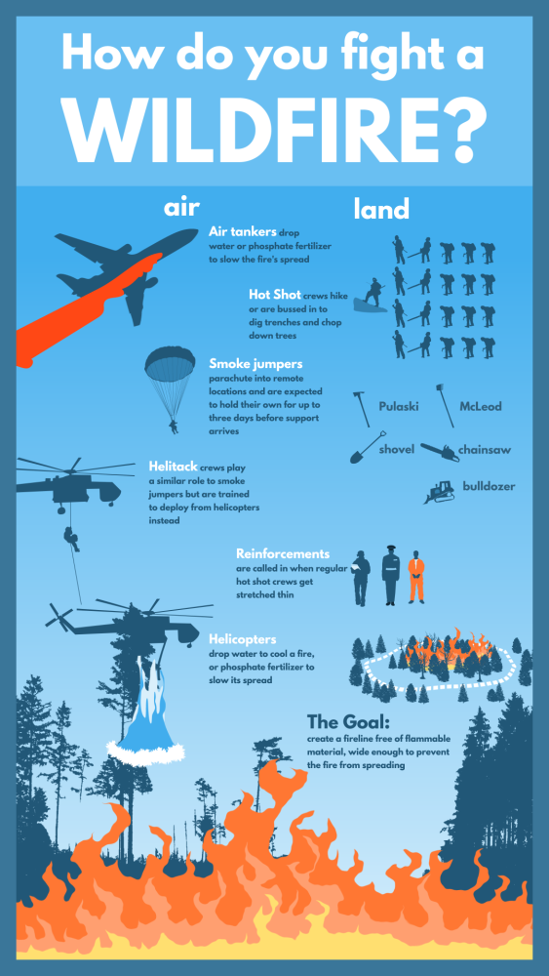
Wildland firefighting. How hard could it be, possibly? Well…it’s harder than it looks and sounds. Unlike structural firefighting, where the goal is to completely extinguish the fire, in wildland firefighting, the overall goal is to have the fire contained.
What’s a “fireline?” Glad you asked. Wildland firefighters are tasked with the back breaking work of using tools, as noted on the Infographic above, to dig and clear a perimeter around the fire. Once flammable vegetation and material is cleared, the fire will be contained to the spot, where, without the necessary fuels, it will eventually burn itself out. Unlike in structural firefighting, water is rarely used.
What are “Hot Shot” crews? They are the elite of the wildland fire world. Hot Shots are assigned to the most tedious fires, in the more unforgiving locations – that most fire crews would refuse to go to. But Hot Shots are conditioned to have no fear!
The smokejumpers deserve a huge shout out as well. Jump out of a plane into a wildfire? Want to do it? That’s okay…me neither! As said, smokejumping is a job for the elite few.
Wildfires are on the rise all around the world – and more and more resources are needed to be trained to fight them. Think you’ve got what it takes? Train for the “pack test” – a three mile walk wearing a 45 pound pack in 45 minutes or less! Sound like fun? Yeah, I’ve always enjoyed it!
So…want to fight wildfires? Get that training started! A love for the outdoors and backpacking doesn’t hurt either! Don’t get me wrong, I love my structural brothers and sisters but…wildland’s where it’s at for me!

