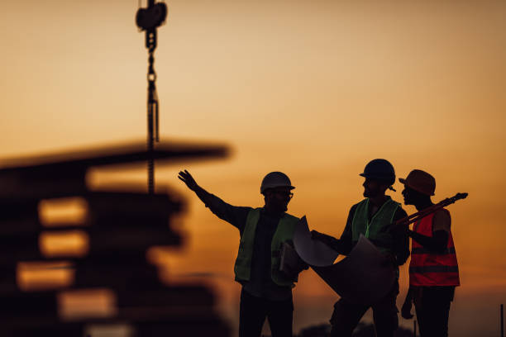

Construction

Construction is a general term meaning the art and science to form objects, systems, or organizations, and comes from Latin constructio and Old French construction. To construct is the verb: the act of building, and the noun is construction: how something is built, the nature of its structure

Residential construction
Residential construction may be undertaken by individual land-owners), by specialist , by , by , or by providers of (e.g.: local authorities,). Where local or policies allow, may comprise both residential and non-residential construction (e.g.: retail, leisure, offices, public buildings, etc.).
Residential construction practices, and resources must conform to local building regulations and. Materials readily available in the area generally dictate the construction materials used (e.g.: versus stone versus Costs of construction on a per square meter (or per square foot) basis for can vary dramatically based on site conditions, access routes, local regulations, (custom-designed homes are often more expensive to build) and the availability of skilled tradespeople.
Nonresidential construction

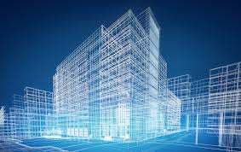
erecting any building or structure designed to be used for any specific use types set forth in Article 8 and includes any other use that is determined by the Planning Director to impact housing demand pursuant to Section 16.89. 710. (SCC 0801 § 1, 1990.)
A non-residential building is one that people do not live in: The architect is best known for designing non-residential buildings. not residential: such as. : not used as a residence or by residents. nonresidential buildings. : not restricted to or occupied by residences
Commercial buildings include apartment complexes, industrial spaces, hotels, retail spaces and office spaces. A residential real estate property is any property that has between one and four residential units. This can include a single-family home, a townhome, a condo, a mobile home, or a multiplex building.
Infrastructure construction projects Include power generation and transmission. These projects can include the construction of the power generation plant. It also will include the facilities and structures necessary to store the power and transmit power.
Types of Infrastructure
- Soft Infrastructure. Soft infrastructure refers to all the institutions that help maintain a healthy economy. ...
- Hard Infrastructure. Hard infrastructure comprises all the physical systems that are crucial to running a modern, industrialized economy.
- Critical Infrastructure
Examples of infrastructure include transportation systems, communication networks, sewage, water, and school systems.
Some construction projects are small renovations or repair jobs, like repainting or fixing leaks, where the owner may act as designer, paymaster and laborer for the entire project. However, more complex or ambitious projects usually require additional multi-disciplinary expertise and manpower, so the owner may commission one or more specialist businesses to undertake detailed planning, design, construction and handover of the work. Often the owner will appoint one business
A construction project is a complex net of construction contrac and other legal obligations, each of which all parties must carefully consider. A contract is the exchange of a set of obligations between two or more
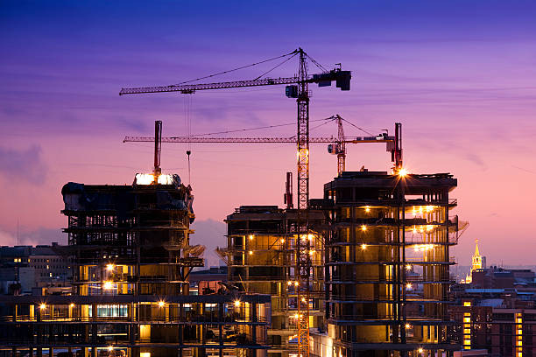
parties, and provides structures to manage issues. For example, construction delays can be costly, so construction contracts set out clear expectations and clear paths to manage delays. Poorly drafted contracts can lead to confusion and costly disputes.
At the start of a project, legal advisors seek to identify ambiguities and other potential sources of trouble in the contract structures, and to present options for preventing problems. During projects, they work to avoid and resolve conflicts that arise. In each case, the lawyer facilitates an exchange of obligations that matches the reality of the project.
The increasing complexity of construction projects creates the need for design professionals trained in all phases of a project's life-cycle and develop an appreciation of the asset as an advanced technological system requiring close integration of many sub-systems and their individual components, including sustainability. For buildings, buildinengineerin is an emerging discipline that attempts to meet this new challenge.
Once contractors and other relevant professionals have been appointed and designs are sufficiently advanced, work may commence on the project site. Typically, a construction site will include a secure perimeter to restrict unauthorised access, site access control points, office and welfare accommodation for personnel from the main contractor and other firms involved in the project team, and storage areas for materials, machinery and equipment. According to the McGraw-Hill Dictionary of Architecture and Construction's definition, construction may be said to have started when the first feature of the permanent structure has been put in place, such as pile driving, or the pouring of slabs or footings.
Some workers may be engaged in manual lab as unskilled or semi-skilled workers; they may be skilled tradespeople; or they may be supervisory or managerial personnel. Under safety legislation in the United Kingdom, for example, construction workers are defined as people "who work for or under the control of a contractor on a construction site in Canada, this can include people whose work includes ensuring conformance with building codes and regulations, and those who supervise other workers
Construction is one of the most dangerous occupations in the world, incurring more occupational fatalities than any other sector in both the United States and in the European Union In the US in 2019, 1,061, or about 20%, of worker fatalities in private industry occurred in construction. In 2017, more than a third of US construction fatalities (366 out of 971 total fatalities) were the result of fall in the UK, half of the average 36 fatalities per annum over a five-year period to 2021 were attributed to falls from height.Proper safety equipment such as harnesses, hard hats and guardrails and procedures such as securing ladders and inspecting scaffolding can curtail the risk of occupational injuries in the construction industry Other major causes of fatalities in the construction industry include electrocution, transportation accidents, and trench cave-ins. Besides that, the high turnover of workers in construction industry imposes a huge
S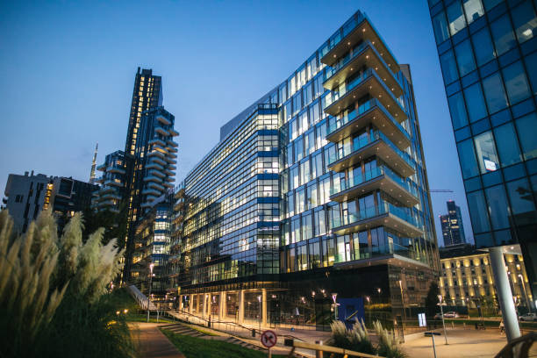
challenge of accomplishing the restructuring of work practices in individual workplaces or with individual workers.
The Indian construction industry employs over 30 million people and creates assets worth over ₹ 200 billion. It contributes more than 5 per cent to the nation's GDP and 78 per cent to the gross capital formation.
The construction Industry in India is expected to reach $1.4 Tn by 2025. Cities Driving Growth - Urban population to contribute 75% of GDP (63% present), and 68 cities will have a population of more than 1 Mn. The construction industry market in India works across 250 sub-sectors with linkages across sectors.
So, if you're considering re-skilling or upskilling, then now is a great time to get into the industry.
- Different sectors within the construction industry.
- Residential building and construction.
- Commercial building and construction.
- Industrial building and construction.
- Heavy civil construction.

Is construction a booming industry
The global construction industry has remained remarkably resilient during the coronavirus pandemic, and it now looks set to be a “global engine for economic growth and recovery from COVID-19,” according to a new report from Marsh, Guy Carpenter, and Oxford Economics.
The future of construction is one that focuses on research and innovation for the good of humanity. Such research must cover an extensive array of themes and scales, taking into consideration all aspects of
While it is not considered one of the best careers in the industry, it is considered one of the best jobs in the country. You can make great money in construction, and there are always job opportunities no matter where you go. Despite the labor shortage, construction needs are on the rise around the world.

he four key types of construction include residential, commercial, industrial, and infrastructure, which covers nearly every construction project
Whether you’re planning to build a small A-frame cabin or you’re the construction manager for a 20-story building, it’s important to know what materials your building needs to stand the tests of time and meet your specific needs.
In fact, there are five building construction types (as determined by the and each one comes with its own set of pros and cons. We’ll walk you through each one so that you can make well-informed decisions for any upcoming projects.
In the end, building construction types will influence the building’s purpose, occupant load, square footage, height, proximity to other structures, windows, exit placements, fire resistance, and the need for sprinklers.
You’ll work with your construction manager and building designer to decide on your construction type, but this article will give an in-depth look into some factors that you should consider. Clearly outlining your needs and requirements before you get too deeply involved in the planning details will save you time, money, and headaches down the road.
Since each type of building construction is associated with unique building materials, they all have different levels of fire protection. Material in the fire-resistive group (Type I) can generally last for three to four hours against fire, whereas for the wood and other structures in Type IV and Type V, it depends on the thickness of the materials used. Therate is about 1 hour of fire resistance per 1.5 inches of wood thickness.
Important Tip: Keep in mind you will need to follow building and local codes, which will help you determine the type of construction you are required to utilize. A building used as an assembly space has different requirements than a building that is for public shopping or a multi-family dwelling. Check with local codes to determine exactly what type of construction you are required to utilize (you can check with us at Stronghold Engineer —we’d be happy to help).

